PLP Presentation Draft

Part 1
1. Presentation Structure
Good afternoon respected judges and dear friends. Today we stand here to describe Ada as a case study in PLP course. Our key point is: Ada provided the best solution for an issue: How can a programming language help us solve the complexity problem when we face a large, long-lived and high error cost software? Let us tell you. First, we’ll elaborate on the Ada background and then cover the language property and our learning experience in part 2. Finally in part 3, we’ll go through its applications and historical impact.

2. Basic Definition
Ada is not a general-purpose language, it was designed for large systems which have clear structure, strong typing and early error detection. Ada codes enabled the develop team to easily review, check and verify the software, and they have very long validity period. These functions came from its visible declarations and block structure (Barnes, 2007). These features are the key to reducing ambiguity in the program, making interface clear and preventing minor errors changing to system-level problems.

3. Appearance Background
To understand Ada’s history and why it appeared, we need to look back to the background of software in 1970s. At that time, systems were getting larger, involving more people and becoming more complex. They became important control components in many areas. Therefore, small program errors could lead to mission delays or serious safety problems. For instance, if something went wrong with flight-support software, the accuracy and safety of the flight cannot be guaranteed. (Carlson et al., 1980; Ichbiah et al., 1979).

What’s more, this is also a result of policy promotion. Large projects used different languages, different dialects, and different local coding habits. That made training and maintenance of the project harder. Due to this, US Department of Defense set up revolutions, wanting to reduce the cost and confusion in defense system caused by that mix. (Whitaker, 1993). Then, Ada emerged as a response because it adds more structure and checking step in the language itself, rather than leaving consistency problem to programmers.

4. The educational value of Ada
Ada is still worth studying nowadays. Although programming tools have changed, core challenges in software remain the same. We still need to determine what the language is intended to convey and what mistakes need to be avoided. What’s more, modern languages all have their own design disadvantages, so Ada provides a useful reference to solve the readability and expensive error-cost problem for them. (Ray et al., 2017; Berger et al., 2019) Now, we move to the second part.

Part 2
- Key features
The most obvious feature of Ada is that it refuses ambiguity. First, Ada is strongly typed, and it can narrow types with ranges or subtypes. The programmer is not limited to saying “this is an Integer”. They can also state valid values from 1 to 10. This is important because many bugs arise from misunderstandings of data types and locations (Barnes, 2007).
Second, Ada makes program structure very visible, because its declarations come before beginning statement, loops end with end loop statement, procedures can close with their own name, so that makes scope easier to see. Ada also keeps state change and ranges explicit that help readers understand what they are reading.

- Tools, compile-run process, and one very small code example
Also, we tried to write a tiny program by Ada ourselves and used the GNAT toochain to finish the work. Our example shows a simple process to sum the numbers from 1 to 10. The process of calculation is not the key to learning, what matters is the steps Ada requires us to do. First, we need an enclosing procedure and following a declaration for Sum as an integer, then clearly define the loop scope, update Sum: = Sum + 1, and finally end the loop visibly. We felt this program was strict, even printing required us to clarify which text I/O package we needed, so it made us notice that Ada never leaves doubts at all.
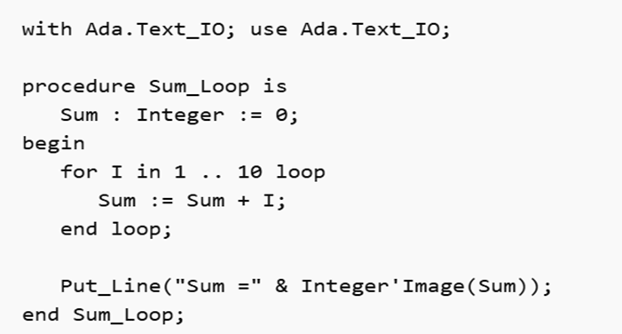
Figure 1 | Ada example: Sum 1 to 10

- Learning experience conclusion
To conclude our learning experience. Our first reaction was that Ada was slow and formal, because we expected the loop to be our work, but it kept asking for surrounding structure and modules. But when we reread the code after running it, our attitude has changed. The parts that seemed fussy at first were exactly what made the program easier to follow. They help to find errors early and make the code easier to maintain (Gao, Bird and Barr, 2017; Bogner and Merkel, 2022).

4. Brief comparison with Python
Now, we compare this loop example with Python. In python project, we can go straight to the task, creating a variable and a loop range, then sum the values and print result. However, Ada reduces workload in different ways that makes all steps more visible. (Prechelt, 2000; Ray et al., 2017). Even the loop notation shows the contrast: Ada writes 1 to 10 in project, while Python writes range (1, 11) and relies on the reader knowing the half-open rule. This reveals the basic difference in design concepts: Python was built for fast initial development while Ada built for saving cost for checking and fixing bugs. (Sward, 2010). Now we will move to part 3.
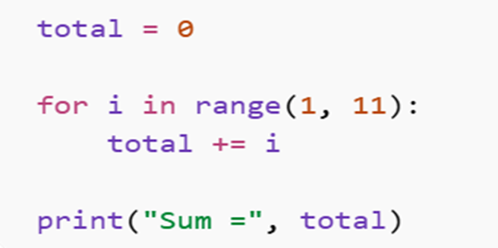
Figure 2 | Python example: Sum 1 to 10

Part 3
- Application domains
In the final part, we want to talk about kinds of Ada systems that are designed to solve practical problems. Among the materials we discovered, Ada provided case studies for Aviation, railway control and signaling, and space systems. In the aviation electronics field, Ada software can support navigation and real-time monitoring for aircrafts like Eurofighter Typhoon aircraft (Snavely et al., 2018; Brandon and Chapin, 2017); On the railway, Ada signal and interlocking software can correctly guide trains and start a safe mode in case of an accident (CENELEC, 2023); In Masten Space Systems, during the tasks that may last for long time and even impossible to achieve, Ada software may help to handle command sequences and managing the instruments and fault (NASA, 2022). These 3 different domains have same properties: High complexity, expensive checking cost, long service life, and extremely low tolerance for hidden faults.

- Reasons fit these domains
To think about why Ada fits these tasks, we need to consider projects’ need from a language. A good project needs codes that reviewers can follow, teams can maintain, and tools can check early. Ada supports these requirements directly: Strong typing can prevent accidental mixing of conceptually different data, ranges and explicit constraints allow programmers to evaluate acceptable values, and the visible block structure makes it easier to check and re-access the control flow (Hoang et al., 2015). This is very important because these codes are read by the testers, reviewers, and other teams, and each change leads to more checks. In this environment, catching errors at the compile stage is much better than discovering them during integration or operation. Therefore, Ada achieves these functions by incorporating the necessary process into the language.

- Historical influence and wider significance
From here on, we can broaden our discussion. Ada language may not be a daily language nowadays, but it was still very important historically, not because it’s popular. It is one of the clearest examples of language design which treats correctness, reviewability, and long-term maintenance as issues. It helps to form stringer interfaces between program units, with independent standards and implementations (Whitaker, 1993; Sward, 2010). Some people say that modern languages are simpler than Ada, or that every feature nowadays originated from Ada. This is inappropriate. The greater significance of Ada lies in its analytical nature, which makes the balance between security and performance in the program clear. That’s why it still helps us to carefully think about modern languages.

- Conclusion
Ada is worthy of study not only for its historical interest. It originated from an engineering problem. When we try to write code, it feels very strict, but it ensures that the software remains secure and user-friendly for a long time. This reveals that Ada makes the language priorities clear. It emphasizes the importance of software readability, early error detection, and long-term maintenance, laying a solid foundation for the progress of programming languages. Thank you!

References
Barnes, J. (2007) Rationale for Ada 2005. Available at: https://www.adaic.org/resources/add_content/standards/05rat/Rationale05.pdf (Accessed: 18 April 2026).

Berger, E.D., Hollenbeck, C., Maj, P., Vitek, O. and Vitek, J. (2019). On the Impact of Programming Languages on Code Quality. ACM Transactions on Programming Languages and Systems, 41(4), pp.1–24. doi:https://doi.org/10.1145/3340571.

Bogner, J. and Merkel, M. (2022). To Type or Not to Type? A Systematic Comparison of the Software Quality of JavaScript and TypeScript Applications on GitHub. [online] IEEE Xplore. doi:https://doi.org/10.1145/3524842.3528454.

Brandon, C. and Chapin, P. (2017). The Use of SPARK in a Complex Spacecraft. ACM SIGAda Ada Letters, 36(2), pp.18–21. doi:https://doi.org/10.1145/3092893.3092896.

Carlson, W.D., Druffel, L.E., Fisher, D.E. and Whitaker, W. (1980). Introducing Ada. 1980 Proceeding. doi:https://doi.org/10.1145/800176.809976.

CENELEC (2023) EN 50716:2023 Railway applications — Requirements for software development. Brussels: European Committee for Electrotechnical Standardization. Available at: https://standardsdevelopment.bsigroup.com/projects/2022-00241 (Accessed: 29 April 2026).

Gao, Z., Bird, C. and Barr, E.T. (2017). To Type or Not to Type: Quantifying Detectable Bugs in JavaScript. 2017 IEEE/ACM 39th International Conference on Software Engineering (ICSE). doi:https://doi.org/10.1109/icse.2017.75.

Hoang, D., Moy, Y., Wallenburg, A. and Chapman, R. (2014). SPARK 2014 and GNATprove. International Journal on Software Tools for Technology Transfer, 17(6), pp.695–707. doi:https://doi.org/10.1007/s10009-014-0322-5.

Ichbiah, J., Bernd Krieg-Brueckner, Wichmann, B., Barnes, J., Olivier Roubine and Jean-Claude Heliard (1979). Rationale for the design of the Ada programming language. Sigplan Notices, 14(6b), pp.1–261. doi:https://doi.org/10.1145/956653.956654.

NASA (2022) NASA-STD-8739.8B: Software Assurance and Software Safety Standard. Washington, DC: National Aeronautics and Space Administration. Available at: https://standards.nasa.gov/sites/default/files/standards/NASA/B/0/NASA-STD-87398-Revision-B.pdf (Accessed: 29 April 2026).

Prechelt, L. (2000) ‘An empirical comparison of seven programming languages’, Computer, 33(10), pp. 23–29. doi:10.1109/2.876288.

Ray, B., Posnett, D., Devanbu, P. and Filkov, V. (2017). A large-scale study of programming languages and code quality in GitHub. Communications of the ACM, [online] 60(10), pp.91–100. doi:https://doi.org/10.1145/3126905.

Snavely, W., Meyers, C., Runyon, B., Inacio, C., Riley, M. and Lareau, J.D. (2018) ‘Flight software programming language selection: a security perspective’, 2018 AIAA SPACE and Astronautics Forum and Exposition. doi:10.2514/6.2018-5397.

Gao, Z., Bird, C. and Barr, E.T. (2017). To Type or Not to Type: Quantifying Detectable Bugs in JavaScript. 2017 IEEE/ACM 39th International Conference on Software Engineering (ICSE). doi:https://doi.org/10.1109/icse.2017.75.

Sward, R.E. (2010). The rise, fall and persistence of Ada. ACM SIGAda Ada Letters, 30(3), p.71. doi:https://doi.org/10.1145/1879097.1879081.

Whitaker, W.A. (1993). Ada—the project. ACM SIGPLAN Notices, 28(3), pp.299–331. doi:https://doi.org/10.1145/155360.155376.

